# Assignment 1

***Here are the code and snapshots for creating a Bound Service using Messenger:***

Follow the steps described in this Android Tutorial:

**Step 1:** Create a **new Android Project with the class name MainActivity**.

**Step 2:** Add two buttons in layout and name them as **play and stop**.

**Step 3:** **Set the onClick Listeners of both buttons** inside the MainActivity.

**Step 4:** **Create a new class** “MyService” and extends it to Service Class

**Step 5:** Make a **new folder named as “raw” inside the “res” directory**, and copy a song inside it.

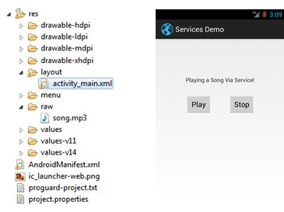

Tag to add in Manifest:

<service android:name=*“.MyService”*  android:enabled=*“true”* > </service>

**Code : MainActivity.java**

**public** **class** MainActivity **extends** Activity {

@Override

**protected** **void** onCreate(Bundle savedInstanceState) {

**super**.onCreate(savedInstanceState);

setContentView(R.layout.*activity_main*);

Button play, stop;

play = (Button) findViewById(R.id.*button1*);

stop = (Button) findViewById(R.id.*button2*);

play.setOnClickListener(**new** View.OnClickListener() {

@Override

**public** **void** onClick(View v) {

Intent service = **new** Intent(MainActivity.**this**, MyService.**class**);

startService(service);

}

});

stop.setOnClickListener(**new** View.OnClickListener() {

@Override

**public** **void** onClick(View v) {

Intent name = **new** Intent(MainActivity.**this**, MyService.**class**);

stopService(name);

}

});

}

}

**Code: MyService.java**

**public** **class** MyService **extends** Service {

MediaPlayer mp;

@Override

**public** IBinder onBind(Intent arg0) {

**return** **null**;

}

@Override

**public** **void** onCreate() {

**super**.onCreate();

mp = MediaPlayer.*create*(getApplicationContext(), R.raw.*song*);

}

@Override

**public** **int** onStartCommand(Intent intent, **int** flags, **int** startId) {

mp.start();

**return** 0;

}

@Override

**public** **void** onDestroy() {

mp.release();

**super**.onDestroy();

}

}